**CHAPTER THREE**

# **3.1 Career assessment tools**

Career assessment tools are instruments designed to help individuals explore their interests, strengths, and skills.

They can help students identify their career aptitudes and motivations, and fit with different occupations and work environments. Career assessment tools can also help students plan their education, training, and development based on their career goals and aspirations.

They are used in career guidance to enable the learner to identify and explore their interests, skills, personality, values, and goals, thereby providing information, insights, and feedback to support one in making an informed career choice and decision.

This is known as self-awareness or self knowledge, which is the ability to understand oneself and the influences it has on one’s career choice. Self awareness is the first step in helping students understand themselves before they look at their grades. The terms popularly used in assessment tools are as follows;

**Interests :**Interests refer to the activities, subjects, or fields that a person enjoys and is curious about.They are either innate (inborn) or acquired.

**Skills:** Skills refer to the abilities and expertise that a person has acquired through learning, practice, or experience

**Personality:** Personality describes the characters that are reflected in one’s behavior and the way one interacts with people around them.

**Values:** Theseare the fundamental beliefs or principles that guide a person’s behavior, decisions, and interactions with others**.**

**Talents:** refer to natural abilities or aptitudes that individuals possess.

***Abilities*:** capacity to do something effectively, e.g., working with numbers

# **3.2 Different Assessment tools and how they work**

Career assessment tools play a crucial role in helping learners plan their careers by providing insights into their strengths, interests, values, and skills. Here are some ways these tools are used in career planning:

1. Self-Awareness: Career assessments help learners understand their own preferences, strengths, and weaknesses.
2. Career Exploration: Once learners have a better understanding of themselves, they can explore various career options that align with their profiles
3. Decision Making: With the information gathered from self-assessments and career exploration, learners can make more informed decisions about their career paths.
4. Goal Setting: Career assessments can help learners set realistic and achievable career goals.
5. Personalized Guidance: Career counselors often use assessment tools to provide personalized advice to learners.

## **3.2.1 Interest Inventory Tool**

This is a popular career assessment tool developed by psychologist John L. Holland. It helps individuals identify their career interests and match them with suitable job environments. Holland was an Industrial Psychologist who conducted research to find out why some people were so motivated at work, innovative, and found satisfaction, while others were very dissatisfied given the same circumstances. Holland’s study led him to understand the connection between interests and motivation. He developed the theory of trait – factor of career choices which described a match between interests and work tasks that led to motivation, satisfaction and better performance. A mismatch between interests and work tasks led to de-motivation, de-satisfaction and poor performance.

He loosely categorized peoples’ interests into six major areas and work environment to become known as the Holland codes: Realistic (**R**), Investigative (**I**), Artistic (**A**), Social (**S**), Enterprising (**E**) and Conventional (**C**)

The Model is used to provide a unique opportunity for self-exploration allowing the learner to take responsibility for discovery of their own interests, thereby guiding them towards suitable career paths. The tool offers valuable resources for anyone looking to navigate their career journey effectively.

Below is a RIASEC self-assessment tool where learners are expected to respond to various statements related to questions on interests. These questions are structured in a way that allows preferences across six personalities. There are no right or wrong answers. Please follow the instructions below.

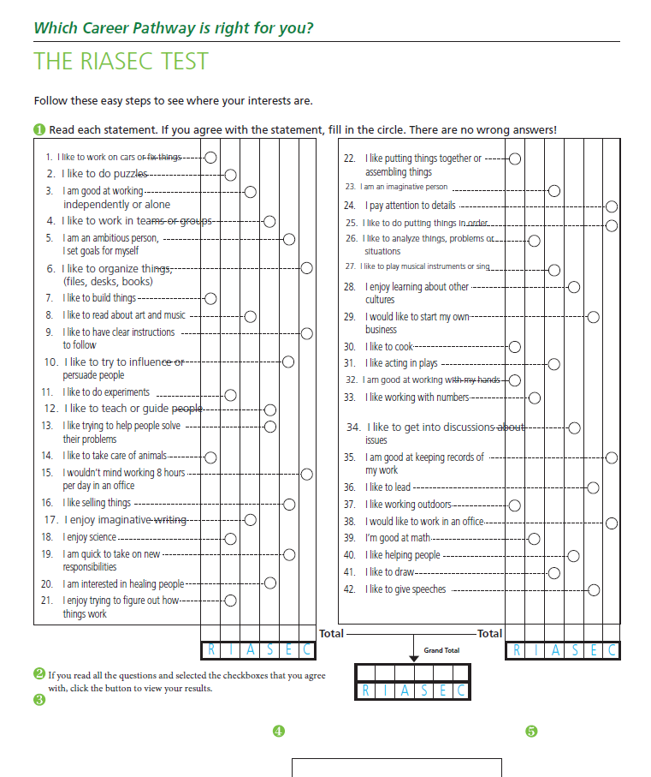

1. Add up the number filled circles in each column and then add the two columns together for grand total
2. Using your grand total scores from above, transfer the scores for each letter into the appropriate column

R= Realistic Total

I= Investigate Total

A= Artistic Total

S= Social Total

E= Enterprising Total

C= Conventional Total

1. Take the 3 letters with the highest scores and record them under “My interest Code”

MY INTEREST CODE — — —

**RIASEC Tool Interpretation:**

The interpretation of the RIASEC assessment results involves understanding how an individual's scores across the six personality types—Realistic, Investigative, Artistic, Social, Enterprising, and Conventional—reflect their interests, preferences, and potential career paths based on how you responded to the questions.

Realistic (R):

Realistic persons, commonly known as doers are practical, hands-on, may love to operate tools, machinery, equipment, working with plants or animals. They are often outdoorsy, mechanical, reliable and athletic. They value practical things that can be seen and touched.

**Typical abilities**

1. Mechanical abilities
2. Skills in operating heavy equipment, driving, piloting
3. Manual dexterity
4. Abilities in building structures
5. Physical coordination
6. Taking physical risks
7. Concrete Problem solving

**Activities**

1. List careers that align with the Realistic attribute
2. Link the learning area that you are currently undertaking and aligns to the realistic attribute

Investigative (I):

Commonly known as thinkers, investigative type of learners are curious, inquiring, probing, questions (why and how), researches, analyses and investigates. They love working independently and solving complex problems.

**Investigative** likes to study and solve math or science problems; generally, avoids leading, selling, or persuading people. They are good at understanding and solving science and math problems. They see themselves as precise, scientific, and intellectuals.

Typical abilities

1. Researching
2. Analytical
3. Problem solvers
4. Finding out how things work
5. Experimenting and testing theories
6. Calculative

**Activities**

1. List careers that align with the Investigative attribute
2. Link the learning area that you are currently undertaking and aligns to the Investigative attribute

Artistic (A)

Known as creators, artistics are creative, expressive, original and independent. They like to do creative activities like art, drama, crafts, dance, music, or creative writing; generally, avoids highly ordered or repetitive activities.

**Typical abilities include**

* Acting
* Writing and reporting
* Musical expression
* Sculpting, photography, painting etc.
* Creative design through use of colour

**Activities**

1. List careers that align with the Artistic attribute
2. Link the learning area that you are currently undertaking and aligns to the Artistic attribute

Social (S)

Social people are people-oriented, often in roles that involve helping or teaching others. They see themselves as helpful, friendly, trustworthy and enjoy solving social problems.

**Typical abilities include**

* Teaching
* Facilitating
* Counseling
* Empathetic Listening
* Serving

**Activity**

* List careers that align with the Social attribute
* Link the learning area that you are currently undertaking and aligns to the Social attribute

Enterprising (E)

Known to be ambitious and persuasive, they are typically found in leadership or entrepreneurial roles. They see themselves as energetic, ambitious, and sociable. Enterprising persons to lead and persuade people, sell things and ideas; and generally avoids activities that require careful observation and scientific, analytical thinking;

**Typical abilities include**

* Public Speaking
* Selling
* Leading
* Adventure
* Taking Action
* Persuading

**Activity**

* List careers that align with the Enterprising attribute
* Link the learning area that you are currently undertaking and aligns to the Enterprising attribute

Conventional (C)

Known to be detail-oriented, they often thrive in systematic and structured environments. They often like working with numbers, records, and in an orderly way. They generally avoid ambiguous, unstructured activities and love following a set plan.

**Typical abilities include**

* Organization
* Attention to detail
* Mathematical abilities
* Stewardship
* Methodical
* Neat and Tidy

**Activity**

* List careers that align with the Conventional attribute
* Link the learning area that you are currently undertaking and aligns to the Conventional attribute

**Overall activities:**

1. **List five activities that you thoroughly enjoy. For example Planting, debating, sports, politics, painting, cooking or conservation activities**

|  |  |
| --- | --- |
| **Five activities that I enjoy** | **What I enjoy about them** |
|  |  |

***Note: The reason for engaging in your activity of choice will give some clues into your areas of interest***

1. ***Pick top two activities that you are mostly interested in/ like***

|  |  |
| --- | --- |
| **Five activities that I enjoy** | **What I enjoy about them** |
|  |  |

1. ***Choose your top two career choices that you are interested in or like? ( Senior School?)***

* *I don’t know Fashion Designer*
* *Entrepreneur Performing Artist*
* *Office Administrator Film Production Specialist*
* *Salesperson Content Developer/ Creator*
* *Accountant Advertising Professional/ Digital Marketer*
* *Lawyer Event planner*
* *Logistics Worker Banker*
* *Interior Designer Microfinance Professional*
* *Architect Financial Advisor*
* *Graphic Designer Financial Analyst*
* *Animator Doctor*
* *Nurse Medical Lab/ Technician*
* *Pharmacist Physiotherapist/ Masseur*
* *Healthcare Management/ Professional*
* *Chef*
* *Travel Service Planner*
* *Commercial Pilot*
* *Beautician*
* *Teacher/ Facilitator*
* *Coach/ Trainer*

## **3.2.2. PERSONALITY**

Personality is essentially a collection of distinct qualities, traits and characteristics that define one as an individual. When people create a career direction that aligns with their personality, they are more likely to enjoy their work and feel happy and comfortable. For instance if one is generally a quiet person, they are not likely to enjoy environments where they may be expected to do a lot of talking.

Personality helps to develop character, confidence, and social skills, which are beneficial in both academic and non-academic environments.

**Personality *Assessment:***

The following tool best describes personality traits. As you read through it, select the traits that best describe you.

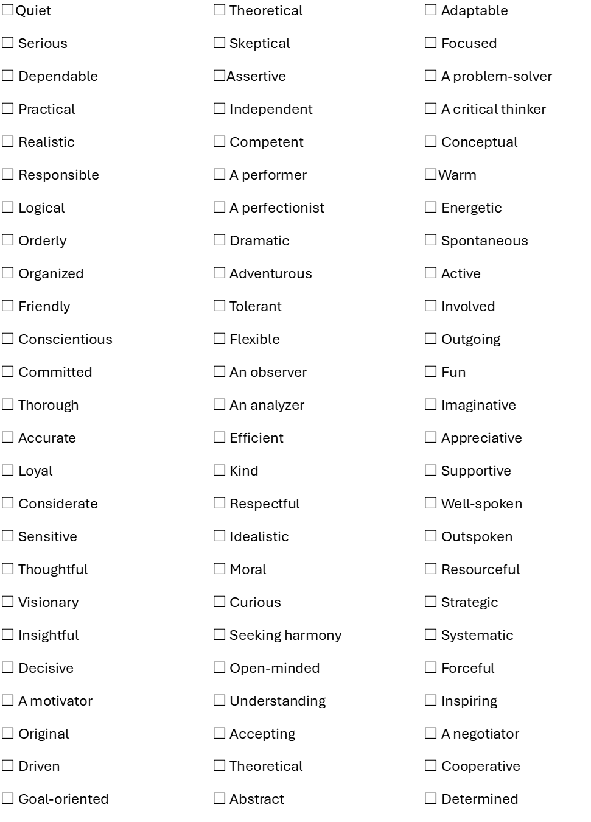

## **Activity**

1. List

## 

## **3.2.3 Aptitude**

**Aptitude-**Aptitude refers to a person's natural ability to learn or perform a specific type of task or activity. In career guidance and counseling, aptitude is a critical factor in helping individuals identify suitable career paths that align with their strengths, skills, and interests.

**About the Tool**: The Test Partnership Tool is an online platform designed to assess cognitive abilities, skills, and personality traits through various customizable tests, often used in recruitment, education, and career development.

**How the Model is Used**: The tool partners with organizations and educational institutions to provide tailored assessments that align with specific needs, such as selecting candidates for roles, placing students in career pathways, or evaluating employee potential.

**Assessment**: It offers a range of assessments including aptitude tests, psychometric evaluations, and skills tests, generating data-driven insights to help make informed decisions in hiring, student placement, or employee development.

## **3.2.4 Attitude**

**Attitude**: Attitude is an individual’s consistent feelings, beliefs, and behavioral responses towards specific objects, people, or situations. It reflects how a person perceives and reacts to their environment, shaped by personal experiences and values.

**About the Tool Used to Assess It**: The **Likert Scale** is a widely used tool to measure attitudes. It consists of a series of statements where respondents express their level of agreement or disagreement on a scale, typically ranging from "strongly agree" to "strongly disagree." This tool captures the intensity of an individual's attitude toward a particular subject.

**How the Model is Used**: The Likert Scale is commonly used in surveys to assess attitudes in fields such as psychology, education, and market research. Respondents evaluate a series of statements related to their views on specific topics. The model provides a simple, scalable method to gauge public opinion, employee satisfaction, or students' attitudes toward learning.

**Assessment**: In a Likert Scale assessment, the responses are scored and analyzed to determine the overall attitude of the individual or group. The results show whether attitudes are positive, neutral, or negative, offering valuable insights for decision-makers to tailor interventions or strategies based on the respondents’ perspectives

## **3.2.5 SKILLS**

Skills assessment tools are essential in career guidance as they help individuals identify their strengths, weaknesses, and areas for development. A skills assessment can be helpful at any stage of your career, like when you:start your career, return to work and progress your career.

**What it achieves:**

* find out what interests and motivates you
* identify your skills
* find out what you can do with the skills you have

**SKILL IDENTIFICATION EXERCISE**

The following checklist can be used to identify the skills you have and which you need to develop. The checklist below can be used to identify the skills you already have and those you think you would enjoy using in a work environment.

**Skill Identification Checklist**

|  |  |
| --- | --- |
| **Skills** | **Actions that can be observed** |
| Accuracy | Pays attention to detail, correct, precise |
| Analytical | Breaks matters into smaller parts, asks the right question. |
| Computer | Utilizes technical software easily. |
| Creative | Uses imagination, generates new ideas. |
| Decision-making | Chooses between different causes of action. |
| Humour | Generates laughter, comedy, amusement. |
| Initiative | Takes the initial step, takes leading action. |
| Interpersonal | Relates well to others, maintains good relationship. |
| Leadership | Influences, directs, models appropriate behaviour. |
| Listening | Understands messages , maintains eye contact, takes notes. |
| Mechanical | Uses tools, equipments, machines. |
| Money management | Budgets, does not overspend, saves. |
| Negotiation | Persuades, has strong oral communication skills, is confident. |
| Numerical | Works out sums, understands arithmetic. |
| Planning | Sets goals, organizes, arranges, prepares. |
| Presentation | Gets the audience's attention, is confident, audible and clear. |
| Problem-solving | Breaks problem into small parts, generates solutions. |
| Researching | Seeks information, asks questions, reads widely. |
| Responsibility | Is dependable, accountable, in-charge. |
| Resourcefulness | Independent, knows where to seek help. |
| Self-management | Manages time, follows schedules independently. |
| Study | Reviews lessons, reads ahead, self assesses, does homework. |
| Teamwork | Works well with others, shares his/her knowledge. |
| Thinking | Has an opinion or views about things. |
| Time management | Creates a to-do list, schedules. |
| Technical | Understands subject matter well. |
| Training | Prepares information well, connects with trainees. |
| Typing | Has good keyboard techniques. |
| Writing | Transmits information clearly from pen to paper. |

The list above is not comprehensive. There are a lot of other skills you use that are not listed above.

1. Identify a recent school, home, work, or volunteer activity that you engaged in. What was the task or activity?
2. What did you enjoy about the task?
3. What didn't you enjoy about the task?
4. Identify at least three skills you acquired or honed as a result of doing this task

## **3.2.6 TALENTS**

Interest is a preliminary indicator of a possible talent. Talents may be artistic, technical, mental, social, and physical. To identify a talent, one must explore several areas of interest to discover the natural abilities an individual possesses.

These can include:

1. Interpersonal abilities: communication, teamwork, and empathy abilities.

2. Creative abilities: aptitudes in artistic endeavors like music, design, or innovation.

3. Analytical abilities: thinking critically, solving problems, and analyzing data.

4. Physical abilities: special abilities related to sports, crafts, or other physical activities.

Understanding one's talents can help individuals make informed career choices that align with their strengths and interests, leading to greater satisfaction and success later in their career lives.

The following are some exercises that can be used by individuals to identify talents inherent in them.Careerpedia Please answer the following questions as honestly as you can:

What comes naturally to you? ................................. ...............

What do you do without being prodded? ....................................

What do you love doing? ..........................................................

What do you find yourself obsessed with? ..................................

What homework do you find most enjoyable? ....................

What 3 positive things have other people noted or said about you? For example, a good public speaker……………………………………………………………………….

What topic are other people tired of hearing you talk about? ..............

Which activity do you have to drag yourself away from? .........................................................................

Take note of achievements that appear more than once. If you had interests in several areas, try them all and see if you enjoy a given activity or if you did the activity more out of curiosity. A natural activity will feel right, and those done for various other reasons will fizzle out in time. Those that remain indicate that the individual has either innate passion or a special ability.

When you find your talent, you are off to a good start. Work on it and keep trying until you get it right,

# 3. 2.7 Values Assessments

Values are the things you believe in and that you feel are important to you. They guide your behaviour and can heavily influence the choices you make in how you live your life. If your values are in conflict with your career, you may end up feeling frustrated or uncomfortable and lose interest in your school or work. Your career will not necessarily align with all of your values, but identifying options that are a good fit with the things that are most important to you is critical for developing a satisfying career.

Now let’s read through the following list and rank how important each is to you using the following scale:

Very Important = This is absolutely essential to you (a must have).

Important = You would like this; It would be good/nice to have.

Neutral = Undecided or don’t care; You feel no strong emotion towards this one way or the other.

|  |  |  |  |  |  |
| --- | --- | --- | --- | --- | --- |
| I Value | Descriptor | Very Important | Important | Neutral | Not Important |
| Security | confident that you can get and maintain a job |  |  |  |  |
| Variety | Frequent changes in your work tasks |  |  |  |  |
| Independence | Working with little or no supervision |  |  |  |  |
| Competition | Opportunity to test your skills or match your performance against others |  |  |  |  |
| Recognition | Acknowledgement and appreciation |  |  |  |  |
| Freedom | Managing your own schedule/ workload |  |  |  |  |
| Status | A position that is admired, respected, prestigious |  |  |  |  |
| Money | Significant financial benefit, making a lot of money |  |  |  |  |
| Creativity | Being expressive, imaginative, and original |  |  |  |  |
| Decision making | Ability to decide how things are done |  |  |  |  |
| Contact | Regular contact with colleagues, customers, clients, students, patients, etc. |  |  |  |  |
| Helping society | Benefiting society as a whole, working for the greater good |  |  |  |  |
| Helping others | Helping individuals or groups |  |  |  |  |
| Excitement | Lots of activity and action |  |  |  |  |
| Belonging | Feeling that you are a part of a group/team |  |  |  |  |
| Excitement | Lots of activity and action  Belonging – feeling that you are a part of a group/team |  |  |  |  |
| Working alone | Doing things on your own, not a lot of involvement with others |  |  |  |  |
| Leadership | Ability to direct and influence others |  |  |  |  |
| Expertise | Being known as someone with special knowledge, skill and ability in a specific area |  |  |  |  |
| Stability | Steady and predictable work opportunities |  |  |  |  |
| Relationships | Having personal and/or professional relationships with people |  |  |  |  |
| Balance | Ability to pursue interest and fulfill commitments outside of school and home |  |  |  |  |
| Fun | Finding pleasure and enjoyment at home, school and friends |  |  |  |  |
| Beauty | Appreciating art, nature, and design; aesthetics |  |  |  |  |
| Technology | Using computers, electronic equipment, and technical software |  |  |  |  |
| Structure | Clear hierarchy, expectations and work arrangements |  |  |  |  |
| Affiliation | Being a part of a recognized group, organization or association |  |  |  |  |
| Individuality | eing unique, follow your own preferences |  |  |  |  |
| Learning | Gaining new knowledge and acquiring new skills |  |  |  |  |
| Spiritual | Fulfilling, feeding your soul |  |  |  |  |
| Serenity | Calm, not a lot of pressure or stress |  |  |  |  |
| Kinesthetic | Using your hands and body; physical activity |  |  |  |  |
| Problem solving | Opportunities to solve problems and develop solutions |  |  |  |  |
| Location | Ability to work and/or live where you want (e.g. urban, rural, overseas) |  |  |  |  |
| Physical challenge | Requiring strength, speed, or agility |  |  |  |  |

Not Important = This is something you could easily do without or may in fact choose to avoid.**Activities**

1. Choose 5 of your “very important values” from above.
2. Reflect (in your journal) if you live by this values. How would you know you were living by them?
3. What would your life look like living by these values?

**Personal Career Plan**

**Resources**

For effective career guidance in junior school, a variety of resources can be utilized to help learners explore different career options and align their interests with their future academic paths. Below are some key resources for career guidance in junior schools:

1. **Books and Literature**

**Career Awareness Books**: Books aimed at introducing learners to different careers in a fun and relatable way.

**Biographies**: Age-appropriate biographies of people in various professions can inspire learners by showing real-life examples of career journeys.

1. **Visual Learning Aids**

**Career Posters and Charts**: Display posters showcasing different career options, industries, and their importance to society. These can be placed in classrooms or common areas to create continuous exposure to career possibilities.

**Infographics**: Create visually appealing infographics on how different subjects and skills in school link to specific career paths

1. **Digital Career Resources**

**Educational Websites and Videos**:Websites and videos that career-related content tailored for younger audiences

1. **Workplace Visits and Field Trips**

**Industry Visits**: Arrange field trips to industries, factories, and offices where learners can observe real-world job settings. This helps them visualize what different careers entail.

1. **Guidance Counselors and Mentors**

**School Guidance Counselors**: Counselors trained in career guidance can provide one-on-one support to help learners reflect on their skills and interests, linking them to future career possibilities.

**Mentorship Programs**: Pairing learners with mentors in various fields helps them get

insights from professionals, particularly in areas of interest.

## StoryMoja: Career Reference to Discover your Career Workbook)

Parking Bay

**How are assessment tools used in Career Planning**

**Career Exploration skills** consist of learning how to identify and analyze various career options in terms of

what education, training, experience, and competencies are required for success. Exploration includes

learning in workplace environments or directly in workplaces to discover and experience what it may be like to

work in different occupations. It also involves learning to evaluate how well a career matches or fits one’s own

interests, skills, strengths, and work values.

**Career and Academic Planning** equips students and their families with the tools necessary to make more

informed choices about secondary and postsecondary career education and training. Students develop a

Graduation Plan is both a learning process and a planning document for academic, career, and technical

education, dual credit coursework, workplace learning, and activities aligned to career goals.